[ Insert official UPAEP logo ]
UPAEP · Decanato de Ingenierías
EVIDENCE — US13-T3
Build the alert history screen
SmartGreenAI: Cilantro Crop

1. Task information
Task ID | US13-T3
User Story | US-13 — View alert history
Sprint | Sprint 3 (2026-10-12 – 2026-10-30)
Week | Week 2
Responsible | Carlos Ramirez Mendoza
Peer reviewer | Jorge Velez Delgado
Planned / actual hours | 2.5 h / 2 h (variance recorded in the Sprint 3 burndown)
Completed on | October 23, 2026
Status | Done

2. Task description
Create the history screen with a table (date, sensor, variable, value, severity, status, resolved at), filters and a CSV export button.

3. Completion conditions
✓ Condition 1: The table shows all required columns.
How it was verified: The table shows date, sensor, variable (type), value, severity, status and resolved at (plus the message and acknowledgement).
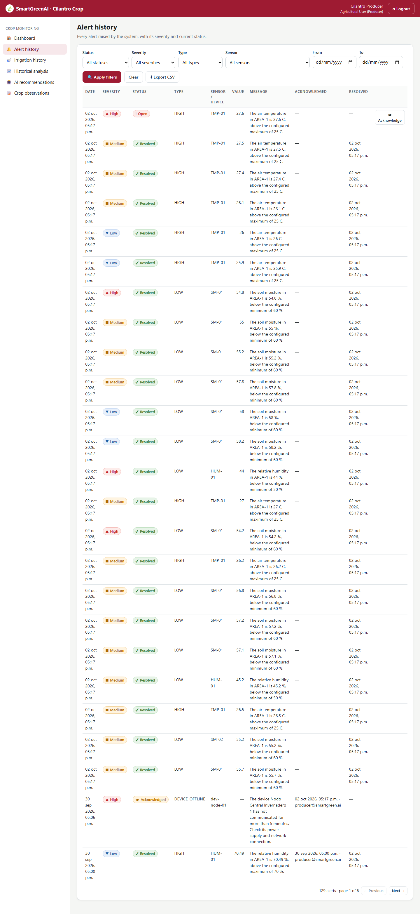
Figure US13-T3-1. Alert history: date, severity, status, type, sensor, value, message, acknowledgement and resolution time. (US13-T3_Build_Alert_History_Screen_1.png)
✓ Condition 2: Filters update the table.
How it was verified: Filters update the table (14 alerts · page 1 of 1).
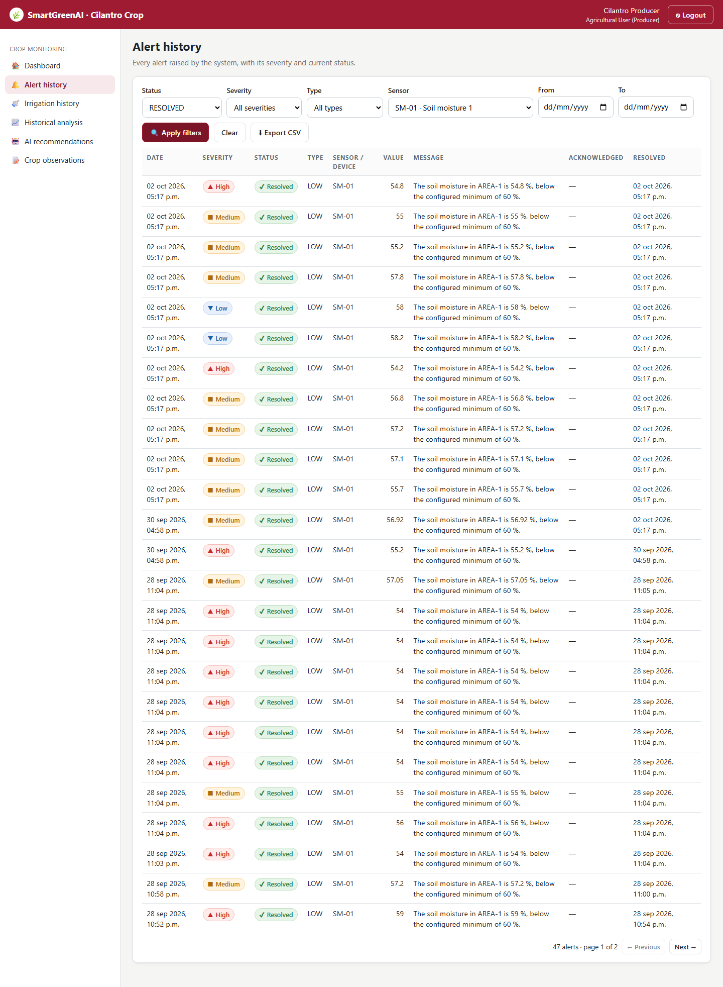
Figure US13-T3-2. Filters applied (sensor SM-01, status Resolved): the table updates. (US13-T3_Build_Alert_History_Screen_2.png)
✓ Condition 3: CSV export downloads the filtered rows.
How it was verified: The Export CSV button downloaded 14 rows with the same filters (every row is SM-01 / RESOLVED: true).
Exported CSV (first lines) (attached: US13-T3_Build_Alert_History_Screen_3.csv)
Date,Sensor,Variable,Value,Unit,Threshold min,Threshold max,Type,Severity,Status,Message,Acknowledged by,Acknowledged at,Resolved at
2026-09-29T04:38:11.766Z,SM-01,soil_moisture,54.8,%,60,80,LOW,HIGH,RESOLVED,"The soil moisture in AREA-1 is 54.8 %, below the configured minimum of 60 %.",,,2026-09-29T04:38:12.073Z
2026-09-29T04:38:11.710Z,SM-01,soil_moisture,55,%,60,80,LOW,MEDIUM,RESOLVED,"The soil moisture in AREA-1 is 55 %, below the configured minimum of 60 %.",,,2026-09-29T04:38:11.739Z
2026-09-29T04:38:11.649Z,SM-01,soil_moisture,55.2,%,60,80,LOW,MEDIUM,RESOLVED,"The soil moisture in AREA-1 is 55.2 %, below the configured minimum of 60 %.",,,2026-09-29T04:38:11.679Z
2026-09-29T04:38:11.589Z,SM-01,soil_moisture,57.8,%,60,80,LOW,MEDIUM,RESOLVED,"The soil moisture in AREA-1 is 57.8 %, below the configured minimum of 60 %.",,,2026-09-29T04:38:11.613Z
2026-09-29T04:38:11.530Z,SM-01,soil_moisture,58,%,60,80,LOW,LOW,RESOLVED,"The soil moisture in AREA-1 is 58 %, below the configured minimum of 60 %.",,,2026-09-29T04:38:11.561Z
2026-09-29T04:38:11.472Z,SM-01,soil_moisture,58.2,%,60,80,LOW,LOW,RESOLVED,"The soil moisture in AREA-1 is 58.2 %, below the configured minimum of 60 %.",,,2026-09-29T04:38:11.499Z
2026-09-29T04:38:06.852Z,SM-01,soil_moisture,54.2,%,60,80,LOW,HIGH,RESOLVED,"The soil moisture in AREA-1 is 54.2 %, below the configured minimum of 60 %.",,,2026-09-29T04:38:11.235Z

✓ Condition 4: Evidence: Screenshot of the history with filters applied and the exported CSV.
How it was verified: Screenshot of the history with filters applied and the exported CSV.

4. Attached files
- US13-T3_Build_Alert_History_Screen_1.png
- US13-T3_Build_Alert_History_Screen_2.png
- US13-T3_Build_Alert_History_Screen_3.csv

5. Traceability
Related requirements | FR-15, FR-22
Implementation | public/producer/alerts.html, public/js/pages/alerts.js (filters, pagination, CSV)
Verification | screenshot

6. Sign-off
Role | Name | Date | Signature
Responsible | Carlos Ramirez Mendoza | October 23, 2026
Peer reviewer | Jorge Velez Delgado | October 23, 2026
Product Owner acceptance | Alexis Enrique Valle Parra | October 23, 2026
Approval record: Daily Meeting 3 of Sprint 3 (Monday, October 26, 2026), team update, Carlos Ramirez Mendoza (by chat): "uploaded the evidence of US13-T3, alert history screen." Daily Meeting 3 of Sprint 3 (Monday, October 26, 2026), Scrum board: "Tasks moved to Done last week: US11-T3, US11-T4, US11-T5, US12-T2, US13-T3, US15-T6, US15-T7, US16-T3, US16-T4, US17-T2, US19-T4, US19-T5, US19-T6."

